**INVEST** is an acronym to help teams write high-quality, specific user stories that are independent, negotiable, valuable, estimatable, small, and testable.

1: Independent- User stories should be self-contained and independent of one another.

Example:

User Story: As a user, I want to be able to reset my password so that I can regain access to my account if I forget it.

2: Negotiable- User stories should be open to negotiation and discussion between the development team and product owner.

Example:

User Story: As a user, I want to filter search results by price range so that I can find products within my budget.

3: Valuable-User stories should deliver value to the end user or customer.

Example:

User Story: As a customer, I want to receive email notifications when my order ships so that I can track its delivery status.

4: Estimable - Teams should be able to estimate how long it will take to implement a user story and what resources will be required to complete it.

Example:

User Story: As a user, I want to be able to add items to my shopping cart so that I can purchase them later.

5: Small- Breaking down larger features into smaller, so it helps to reduce the risk.

Example:

User Story: As a user, I want to be able to view product reviews on the product detail page so that I can make informed purchasing decisions.

6: Testable- They should have acceptance criteria to check whether we fullfied the customer needs or not.

Example:

User Story: As a user, I want to be able to sort search results by relevance, price, and customer ratings so that I can find the most suitable products.

**EPIC:** An epic is a large body of work that can be broken down into smaller tasks or stories.

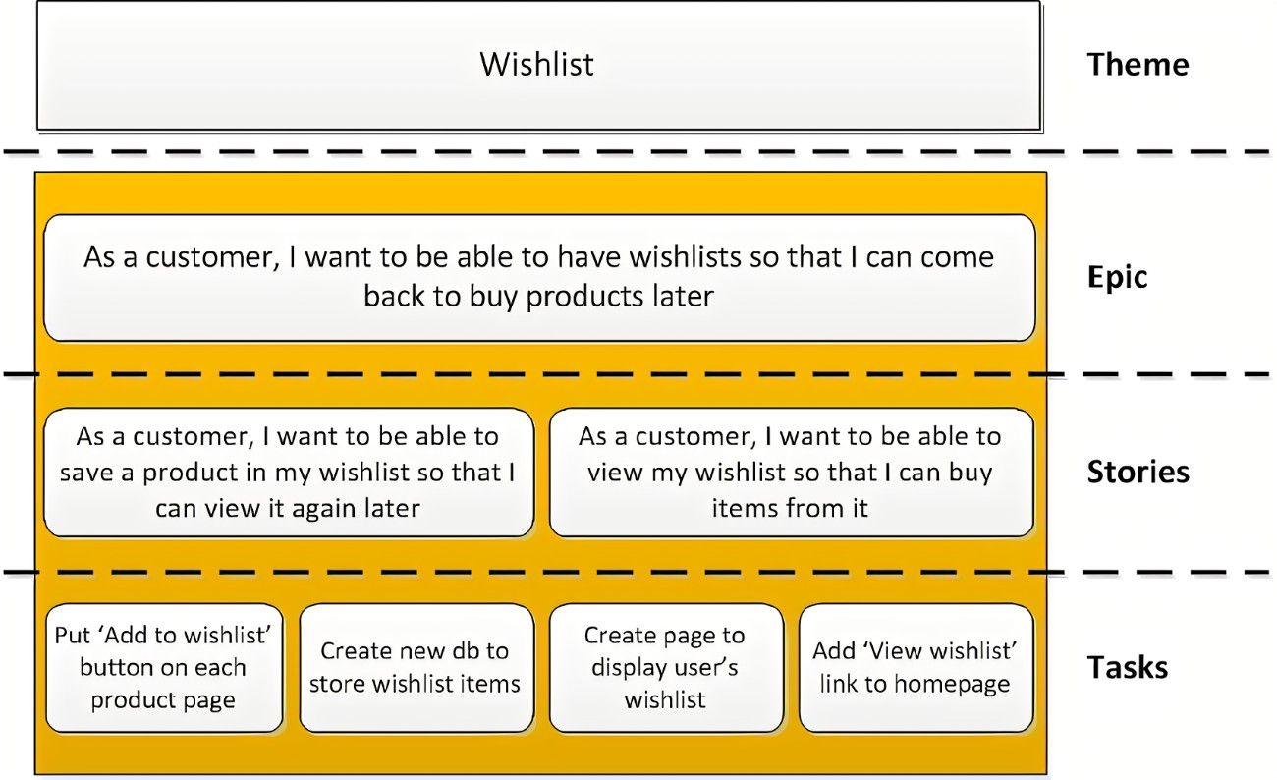

**Product Backlog:**

The product backlog is the **list of all the work that needs to get done**.

It usually contains user stories, bugs, technical tasks, and knowledge acquisition.

**SCRUM:**

Scrum is a framework within the Agile methodology that is used to manage complex software development projects.

That helps to teams to work together, manage works and solve problems in short cycles.

Scrum has a set of practices,artificates and roles that implements the principle of agile